**IBM POWERED EARLY WARNING**

**SYSTEM FOR TRIBAL PEOPLE ON WILD PREYING**

**1. INTRODUCTION**

**1.1 Overview**

Tribal people constitute 8.6% of the nation's total population, and most of them spend the greater part of their lives in the proximity of trees and villages or clans near to the forest. There are so many challenges faced by these people out of which Human-wildlife conflict is a serious challenge undermining the protection of tribal regions. The major types of human-wildlife conflict in the area include crop-raiding, livestock predation, increased risk of livestock diseases, and direct threats to human life. So Active measures are to be implemented to mitigate these problems and safeguard the future of the wildlife.

**1.2 Purpose**

Early warning system ensures the complete safety of humans who lives near the forests by notifying the wild animal predation before it enters the clan.

**2. LITERATURE SURVEY**

**2.1 Existing problem**

The challenges of human–wildlife conflict are older than recorded history but an interdisciplinary field of study focused on human–wildlife conflict and coexistence, although still relatively new, is growing rapidly. Over the past 20 years, the number of scientific publications addressing human–wildlife conflict and coexistence has increased almost exponentially. The major types of human-wildlife conflict in the area include crop-raiding, livestock predation, increased risk of livestock diseases, and direct threats to human life.

**2.2 Proposed solution**

This project aims to save the lives of tribal by notifying about wildlife predation with the help of Artificial Intelligence. It is a provision of timely and effective information that allows individuals exposed to hazard to take action to avoid or reduce their risk and prepare for effective response.

**3. THEORITICAL ANALYSIS**

**3.1 Block Diagram**

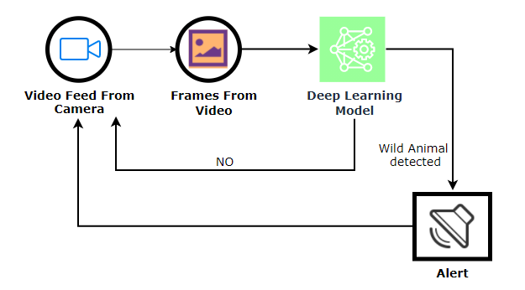

**3.2 Hardware / Software designing**

***Software Requirements:***

* Anaconda Navigator
* Tensorflow
* Keras
* Twilio

***Hardware Requirements:***

* Processor              : Intel Core i5
* Hard Disk Space   : Min 100 GB
* Ram                        : 8 GB
* Display                  : 14.1” Color Monitor(LCD, CRT or LED
* Clock Speed         : 1.67 GHz

**4. EXPERIMENTAL INVESTIGATIONS**

Study shows that it provide with different test images of a wild animals, human, domestic animals. The model detects, if there is any wild animals in the video stream. If the wild animal is detected then an alert message will be sent to higher authorities and alarm sound plays, else it returns no danger. For detecting the animal we create a twilio account. When the wild animal is detected it will give an alert through a message.

**5. FLOWCHART**

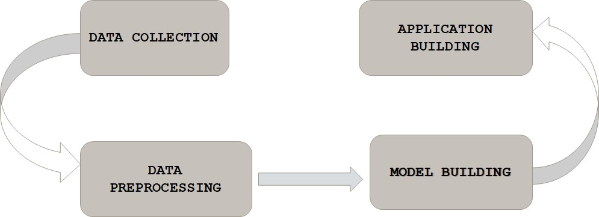

**6. RESULT**

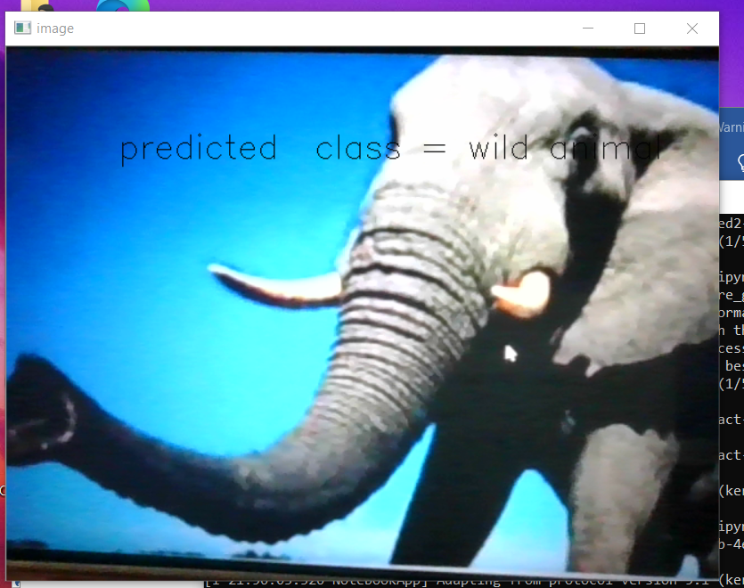

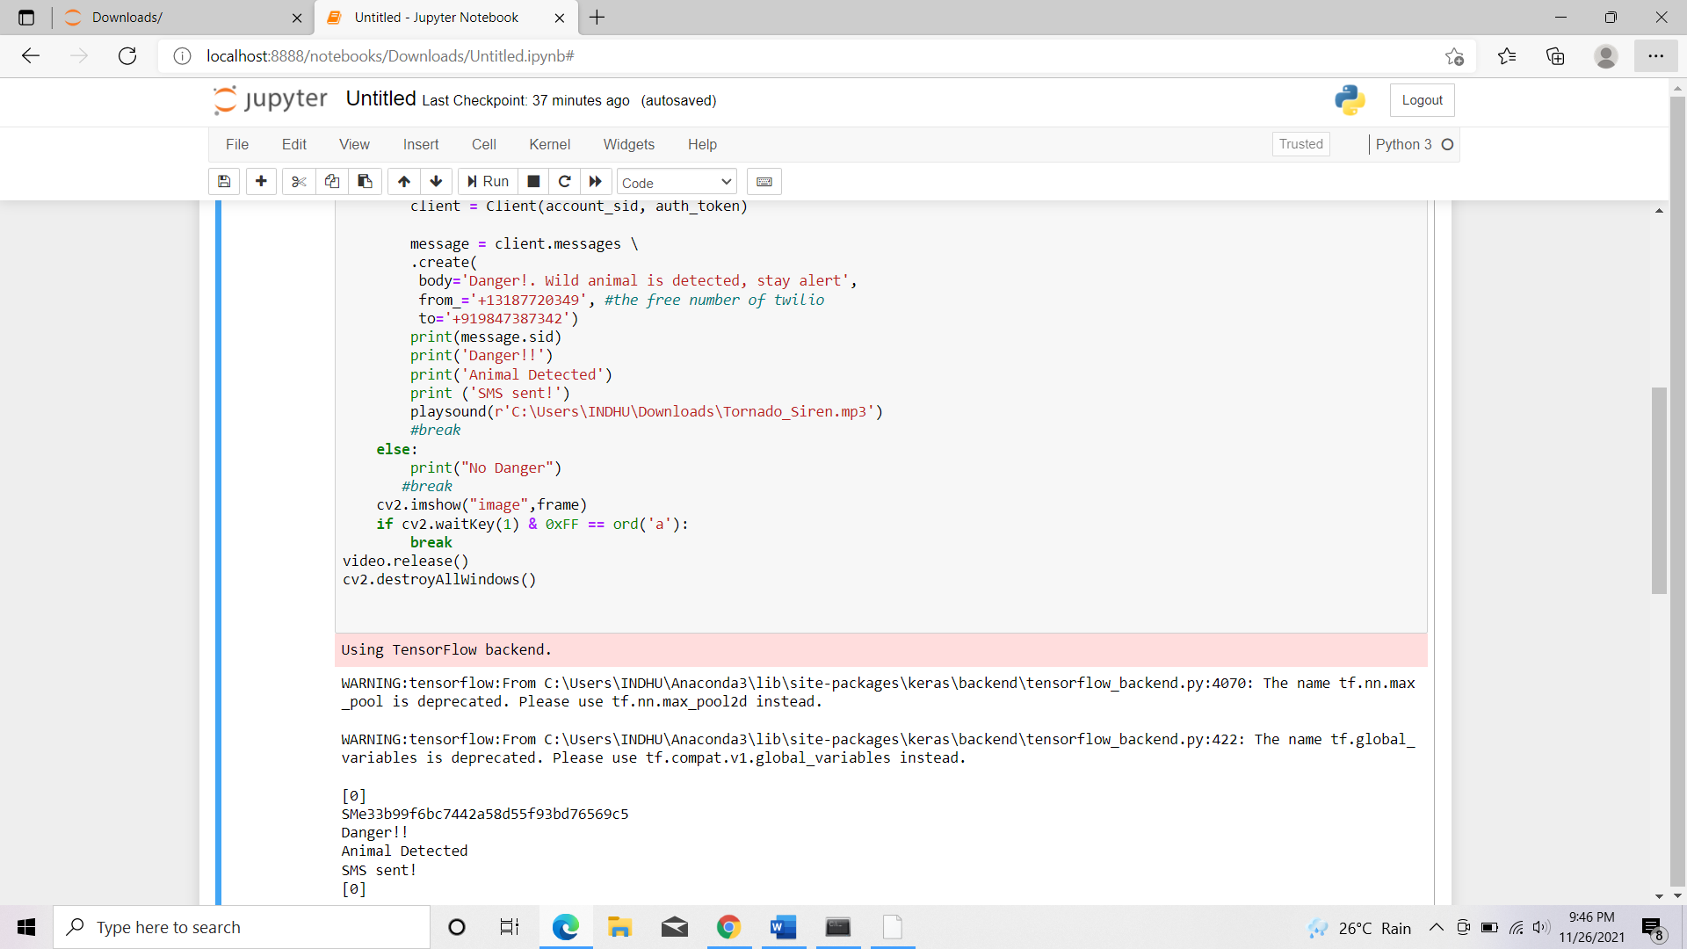

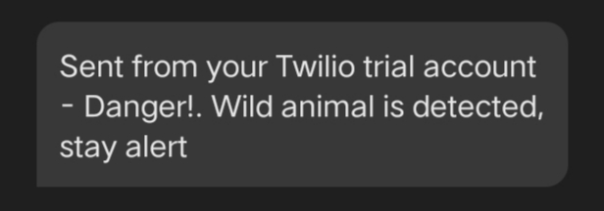

**7. ADVANTAGES & DISADVANTAGES**

***Advantages:***

* Hazard warnings are of great benefit because early warnings save life and property
* Early warning systems help to reduce economic losses and mitigate the number of injuries or deaths from a disaster, by providing information that allows individuals and communities to protect their lives and property.
* Early warning information empowers people to take action prior to a disaster. If well integrated with risk assessment studies and communication and action plans, early warning systems can lead to substantive benefits.
* Effective early warning systems embrace the following aspects: risk analysis; monitoring and predicting location and intensity of the disaster; and communicating alerts.

***Disadvantages:***

* Limitations included their sensitivity, the need for practitioner engagement, the need for reaction to escalation, and the intermittent nature of recording.

**8. APPLICATIONS**

* Wireless Sensor Network (WSN) technology is considered as one of the key technology used in environmental applications.
* Crop-raiding, livestock predation, increased risk of livestock diseases, and direct threats to human life are major types of human-wildlife conflict.
* A wireless sensor network (WSN) based on Internet of Things (IoT) devices and sensors can be used to perform a real-time environmental monitoring of the aforementioned human-wildlife risk factors.

**9. CONCLUSION**

In this project, we have established the application to detect wild animals in the forests to protect tribal people from their attack based on the IBM cloud application. This project aims to save the lives of tribal by notifying about wildlife predation with the help of Artificial Intelligence. It is a provision of timely and effective information that allows individuals exposed to hazard to take action to avoid or reduce their risk and prepare for effective response.

**10. FUTURE SCOPE**

Early warning system is an adaptive measure for climate change, using integrated communication systems to help communities prepare for hazardous climate-related events. A successful EWS saves lives and jobs, land and infrastructures and supports long-term sustainability.

**11. BIBILOGRAPHY**

* Hayden JA, van der Windt DA, Cartwright JL, Cote P, Bombardier C. Assessing bias in studies of prognostic factors. Annals of Internal Medicine.
* Whittington J, White R, Haig K, Slock M. Using an Automated Risk Assessment Report to Identify Patients at Risk for Clinical Deterioration. The Joint commission Journal on Quality and Patient Safety.

**APPENDIX**

**Source Code**

